**Pointillism to Pixels: An analysis of Colour in Landscapes both painted and digital**

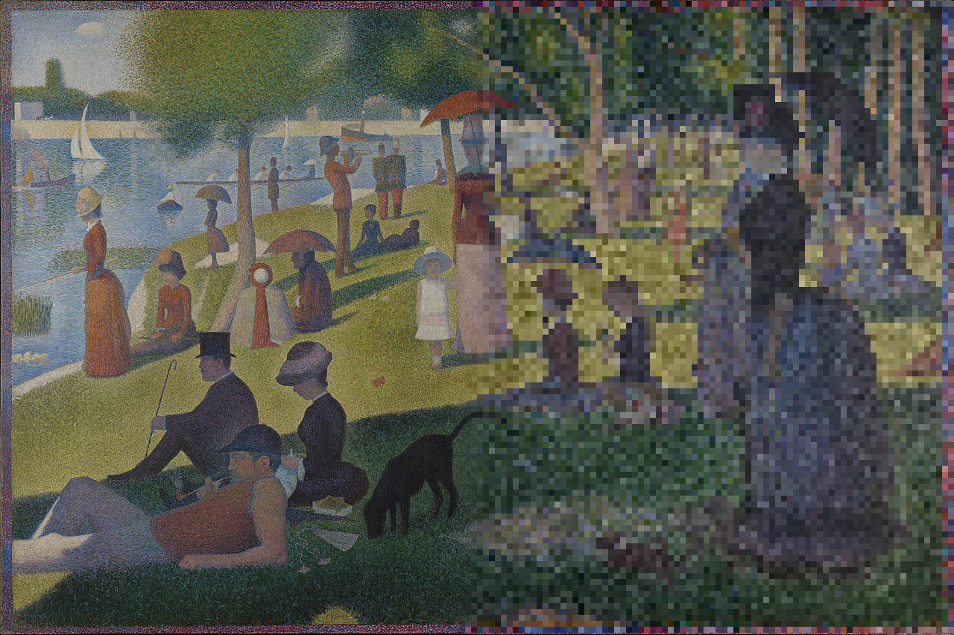

**By Daniel Goldie-Furlong**

**Contents**

List of Figures 3

Chapter 1:

* Introduction
* Colour Theory and Georges Seurat 4
* Claude Monet and John Russell 6

Chapter 2:

* Vincent Van Gogh and Divisionism 7

Chapter 3:

* Post- Impressionism and Digital Animation 6

Chapter 4:

* Conclusion 10

Bibliography and Gallery Visits 11

Appendix: Catalogue of Illustrations 12

**List of Figures**

**Figure 1: Bathers at Asnièrs (1884) Georges Seurat**

**Figure 2: Bathers at Asnièrs - Close up Boys Hat - Georges Seurat**

**Figure 3: A Sunday Afternoon on the Island of La Grande Jatte**

**Georges Seurat (1884-1886)**

**Figure 4: A Sunday Afternoon on the Island of La Grande Jatte Georges Seurat**

**Figure 5: Close up of the face of the young girl in the white dress.**

**Figure 6: Belle Île En Mer (1904) John Russell**

**Figure 7: The Pyramids of Port Coton (1886) Claude Monet**

**Figure 8: The Starry Night (1889) Vincent Van Gogh**

**Figure 9: A Wheatfield with Cypresses (1889) Vincent Van Gogh**

**Figure 10: Image showing the process of scraping paint off a canvas used in *Loving Vincent*.**

**Figures 11, 12 and 13: Images showing the process of 3D modelling and then the final painting used in *Loving Vincent*.**

**Figure 14: Image of points from inkjet printer.**

**Figure 15: Image of different types of pixels up close.**

**Figure 16: Comparison of Aliasing and Anti-Aliasing.**

**Figure 17 and 18: Comparison of different types of dithering.**

**Chapter 1**

**Introduction**

In this essay, I will analyse four artists that I think have made a significant contribution to the development of landscape painting, which can be found today in contemporary art forms. I have had a longstanding interest in Post-Impressionism, having seen many notable works from the movement, and most recently, I took interest in the Australian Impressionists, such as John Russell when I attended an exhibition of Australia’s Impressionists at the National Gallery in London. I was very impressed by Russell’s *Rough Sea, Morestil*, which he painted around 1900. Aside from the evocative use of colour, the impasto technique used greatly interested me, because when viewed close-up, the different brush strokes appear very separate, and no clear image is discernible, while viewed from a distance, the brush strokes merge and form a landscape. This led me to draw parallels between several Post-Impressionist artists and their paintings, with modern day digital media, and the way images are displayed on screens using pixels, which led me to develop my final piece showing the links between painting and digital media.

With my final piece and this essay, I wish to combine both my interest and passion for Post-Impressionism and modern digital media by showing how Post-Impressionism’s colour theory and pointillism has influenced modern day digital display methods. In chapter one, I will discuss Georges Seurat, and the origins of both pointillism and colour theory as developed by Michel Chevreul, as well as the divisionist undertones in the work of Claude Monet and John Russell. In chapter two, I will analyse the work of Vincent Van Gogh, and in chapter three, I link these artists to contemporary, digital art, as well as the World’s first film which was completely animated with oil paintings, “Loving Vincent”, which I was fortunate enough to see at its premiere, along with a live question and answer session with the directors, producers and some artists of the film*.* Because of my longstanding interest in the works of Van Gogh, I was interested to see how the directors of the film expressed Van Gogh’s use of colour, and how it was transferred into an animated film. I believe that this film is very important, because it shows us how Post-Impressionist art can be combined with new digital techniques, to actualise a new experience that compliments the original work.

**Colour Theory and Georges Seurat**

The Post-Impressionists were well known for their use of vibrant, saturated colours. This can be traced back to the work of Michel Eugène Chevreul, a French chemist who devised a concept known as ‘the law of simultaneous contrast’, after being named director of the dye works at the Gobelins Tapestry Works (see Fig. 1) in Paris. He discovered that the black yarn was perceived differently when used next to blue yarn and determined that the yarns observed colour was influenced by the colours of the surrounding yarns. Chevreul’s formation of a colour wheel that illustrated the relation of primary and intermediary hues, as well as the colour theory established by himself, Charles Blanc and Ogden Rood were recorded in a book called ‘Grammaire des arts au dessin’ (1867) which clearly explained theories of colour and perception. Georges Seurat, a French Post-Impressionist was greatly impacted by this book [1] and began to apply colour theory to his own work, devising his own process known as Pointillism. However, it is worth noting that before he began to develop pointillism, Seurat used a technique known as ‘divisionism’ in his earlier works, where a flat brush is used to apply matte colours using strokes in a criss-crossing formation. These strokes become smaller as they approach the horizon.[2]

His later style of pointillism was based on the ‘law of simultaneous contrast’ formulated by Chevreul. This theory explained that the perception of different colours is related to what colours are juxtaposed, and when the colours are viewed together from further away, they ‘blend together’ and show a different colour altogether.[3] This is known as ‘optical blending’ or ‘optical mixing’.[4] This technique of using broken, divided pigments to form a new colour when viewed together was used in his later paintings, but was also worked into parts of one of his earlier paintings, *Bathers at Asnières* (1884) (See Fig 2), and later on, utilised in modern digital display methods, but that will be discussed further on.

Seurat’s *Bathers at Asnières*, which I viewed at the National Gallery in London, is one of his earlier works which uses his divisionist technique, however, he later added points of orange and blue to the boy’s hat in the painting (See Fig 3) and moved towards his later pointillist style. I believe a possible explanation for the pointillist technique using the two colours, was to create a contrast, and a vibrant, luminous effect, which he possibly thought would improve his painting. This original use of contrasting colours creates a highlight and shadow on the hat when viewed from a distance. Apart from this one use of pointillism, *Bathers at Asnières* is a prime example of Seurat’s balayé technique, dancing brushstrokes that relate to Impressionism.[5] This technique can be seen with the grass bank at the front of the painting, as well as the sky and the clouds of smoke in the background, giving the painting a ‘blurry’ or ‘foggy’ effect.

In comparison, *A Sunday Afternoon on the Island of La Grande Jatte* (See Fig 4), painted over two years by Seurat from 1884 to 1886, clearlyshows the pointillist technique. The figures in the painting, as well as the landscape, are coloured by individual pigments; broken, separated points of colour that blend together when viewed from afar to create a whole new pigment. On closer inspection of this painting, focusing on the young girl in the white dress at the centre of the image, we see that Seurat has painted her face in such a way that looking at the painting close-up makes the facial features unrecognizable (See Fig 5). It is not until you step back and look at the whole painting that the face created by the individual points is visible, due to optical blending. Despite this, most of the figures in the painting have very subtle facial features, which are not clearly defined. The painting itself is more or less built upon less clearly defined objects, and it is only through divisionism and mark- making that the forms in the painting become clear. This painting was originally closer in style to *Bathers at Asnières*, originally being painted using the balayé technique, and it was only later that Seurat went over the original painting with his new pointillist style. He did this because he felt the painting was not vibrant enough, and by using the pointillist technique, he was able to increase the brightness of colours. In my view, I feel that the pointillist technique adds a coldness and distance to the composition, whereas the balayé technique reminds me more of traditional impressionist works such as those done by Claude Monet, although it is possibly because of this similarity with the traditional impressionist approach to landscapes that Seurat decided to experiment with pointillism. He was also fascinated with using a more systematic, scientific technique in his work, although “some say they see poetry in my paintings. I see only science.” [6]

**Claude Monet and John Russell**

While Seurat developed his pointillist style, Monet further developed his own style from his previous impressionist works, using some techniques that Seurat employed to create bright landscapes that use contrasting colours. Monet’s use of colour and short brush strokes can also be seen in a lesser-known Impressionist - John Russell, an Australian artist who often worked with Monet during his stay at Belle Île and influenced his style. It was also said that Monet preferred Russell’s paintings of Belle Île rather than his own, although there is no definitive source for this statement. I was fortunate to see some works of John Russell at an exhibition of Australian impressionists at the National Gallery in London in January.

*Belle Île en Mer* (See Fig 6), a painting by John Russell from 1904, clearly shows how Monet has influenced his style of painting. This can be seen through the way he has applied paint to the canvas, as well as his use of bright, saturated colours, although it is worth noting here, that his use of saturated colour is more exaggerated in *Belle Île en Mer* than it is in any of Monet’s paintings of the same landscapes. One of Monet’s works painted on Belle Île, *The Pyramids of Port Coton* (1886) (See Fig 7), uses a more muted palette of green, and orange, with only small specs of red visible, used sparsely, to compliment the dark green at the base of the cliffs, giving them the illusion that the bases of the cliffs have brown in them, when they do not. However, while Russell’s painting uses more saturated colours, Monet’s rendering of the ocean is more realistic, along with the rocks in the ocean. Overall, Russell’s piece is more stylised than Monet’s, but Monet’s influence can still be seen in the way that Russell has painted the background of the piece, as there is a ‘haze’ like quality to it, very similar to the haziness that is viewable in many of his other works. This effect can also be seen in Monet’s *The Pyramids of Port Coton,* which uses this effect to make the sky look as if it is slightly out focus, like taking a photo with a camera. This effect is also used albeit more subtly in Russell’s work.

**Chapter 2**

**Van Gogh and Divisionism**

It is fascinating to see how Seurat’s influence extended to other artists of his time. Having met Seurat at an exhibition at Restaurant du Chalet in November 1887, and then visiting his studio in February 1888 with his brother, Theo, Van Gogh was inspired by his work, including his divisionist technique; although he said “I often think about his system, and yet I won’t follow it at all, but he’s an original colourist, and it’s the same thing for Signac, but to a different degree; the pointillists have found something new, and I like them very much all the same.”[7] Van Gogh did however use a few techniques from divisionism in his own work, such as the separation of colours. In my view this separation of colours is very visible in *The Starry Night (1889) (*see Fig 8), one of Van Gogh’s most well-known paintings.

I think the lack of colour blending in *The Starry Night* creates a larger contrast between the foreground and background, and the large brush strokes consisting of broken colour, form contours around the piece, directing the attention of the viewer to certain areas of the painting. The colour blue dominates the top half of the painting, specifically the artificial pigment ultramarine, while the area surrounding the moon is predominantly cobalt blue, with a smattering of emerald green.[8] Van Gogh uses a technique known as ‘impasto’, where paint is laid on to the canvas thickly, expressing his passion for the scene, creating texture to give the painting a 3-dimensional feeling. In my estimation, the use of impasto in *The Starry Night* adds depth to the composition, making the cypress tree on the right feel further forward, while adding a sense of movement to the swirling cloud in the background. Abstract in form, the whirling cloud in the background perhaps reflects the turbulent emotions that he was feeling at the time, during this particularly troubled period at Saint-Rémy. The undulating, turbulent sky contrasts against the static calmness of the village below, with the church in the midst — a memory from his homeland - The Netherlands.

The stars in the upper portion of the painting exhibit a brightness Van Gogh achieved by contrasting them against the blue sky, painted in Prussian Blue, thus displaying the divisionist technique.

The combined usage of vivid colour and impasto technique used in *A Wheatfield with Cypresses* (See Fig. 9) adds motion to the wheat field, giving the field and olive tree a ‘windswept’ look, and makes the wind suggested on the canvas almost real and tangible. Impasto was also heavily used on the clouds at the top of the piece, with this and the broad, curving strokes adding a sense of depth and texture to the billowing clouds, the contrasting colours of the zinc white and cobalt blue giving the impression of movement. The cool upper half of the painting, with the clouds and sky, is balanced against the warmth and richness of the wheat field below, painted with zinc white and chrome yellow. The wheat field is surprisingly detailed, with the impasto and divisionist technique allowing individual heads of wheat to be visible from each other. Using the elements of colour and technique, Van Gogh has attempted to create a particular effect - the movement of the wheat stalks. The expressive use of colour adds luminance to the painting, with the lightest parts of the wheat field appearing as if they glow slightly, I think the use of chrome yellow and zinc white produce this effect.

**Chapter 3**

**Post-Impressionism and Digital Animation**

As I have discussed in earlier chapters, it is clear that Post-impressionism was prominent in 20th century art. I feel that we can see a resurgence of this art movement today, with many artists, however, using digital tools as means of expression, with a growing trend amongst artists to combine traditional techniques with newer, digital methods. An example of these hybrid works is ‘Loving Vincent’, the world’s first feature length film that has been completely animated in Oil paintings, in the style of Van Gogh. Playing at 12 frames a second, there were over 65,000 individual paintings, painted on over 900 canvases. Space was saved during production by scraping oil paint off a canvas (See Fig 10) where the previous frame was already finished and re-applying paint where necessary to create the next frame of animation.

Loving Vincent presents to us a unique relationship between digital film, and more traditional methods of expression, such as painting, with the original scenes shot using live actors against a green-screen. The video was then put through a filter outlining the characters more easily. Each frame was then projected onto the canvas of one of 125 artists specially trained for the film in animation, as well as in mimicking the style of Van Gogh, and was painted on to a canvas, before being scanned so that every frame could be spliced together to form the final product. The directors of the film, Dorota Kobiela and Hugh Welchman, inspected every painting/frame to make sure that there were no errors in the final film. Errors were corrected by carefully scraping oil paint off the canvas with a palette knife (See Fig 10), the same way that new frames were drawn on top of old ones. Loving Vincent takes Post-impressionist painting techniques, and the style of Van Gogh, combining them with digital workflows to give us an animated oil painting.

Some scenes from the film were rendered first using 3D modelling programs, such as Blender and Maya, and then projected and painted like the others (See Figs. 11, 12 & 13). There was also discussion at the start of the film’s production about completing the entire film using computer generated imagery (CGI), but ultimately it was decided to paint the frames by hand in order to remain faithful to Van Gogh’s original paintings. This is also the reason that, while the film took 7 years to produce, the final feature-length animation only played at 12 frames-per-second (12fps), avoiding extra costs, as well as the extra painting that would follow.

Post-impressionism may not have influenced film directly, but post-impressionism, and more specifically Seurat’s divisionism and Chevreul’s colour theory has had a significant impact on the way modern technology works. One example of colour theory applied in a contemporary situation is in printing. Modern inkjet printers work by firing microscopic points of magenta, yellow, cyan and black ink at paper (See Fig 14). When observed underneath a microscope, these points appear separated, but when looked at from further away, such as when looking at a sheet of paper normally, the four colours blend and produce a variety of different colours - the same technique noticed by Chevreul (The Law of Simultaneous Contrast) in the 19th century when dying wool for his tapestries and used by the post-impressionists such as Seurat to create clearly defined objects with ‘true colour’.

I have also noticed a similar technique at work on modern smartphone cameras; when zoomed in far enough, small dots of colour can be seen, which points to a similarity between the ‘graininess’ of the photo, and some of Seurat’s earlier works, further solidifying the connection between the law of simultaneous contrast and modern digital media.

One more important aspect of technology also uses ‘colour theory’: digital displays and pixels. Pixels work by displaying varying amounts of red, green and blue light (RGB), which when viewed from a distance produce different colours of light, as well as form images which can appear to be realistic (See Figure 15). Each colour seen on a computer monitor is a result of these three colours following the law of simultaneous contrast, and blending together when viewed from further away, similarly to Seurat’s works. Colour theory can also be applied in more pixelated images, especially in compressed images to form gradients or more colours when images have a limited palette of colours (indexed images). A technique called ‘dithering’ (see Figs. 18 & 19) is used, where a computer algorithm uses a limited palette in a similar way to pointillists such as Seurat, by placing differently coloured pixels next to each other to give the illusion of more colours being used. This technique is also used in tapestry making (see Fig 17) when a limited variety of coloured fabric is available. Conventional screens use pixels which can change their brightness to one of 255 values (1 being the darkest, and 255 being the brightest), as such many digital images use bright colours in order to be more contrasting on a computer, when combined with clear pixilation (aliasing – See Fig. 16). It seems to me that even recent digital works have been influenced by pointillism, and still employ pointillist techniques such as the law of simultaneous contrast to portray images, even after more than a hundred years.

I have attempted to demonstrate this through my final piece, through a painting, which combines traditional painting with dithering to show how the process of dithering utilises colour theory in the same way that Seurat’s pointillism and Monet’s seascapes do. This is supported by my video ‘Falaises de Pixelation’ which aims to illustrate the relationship between colour theory and digital display methods, using seascapes similar to those painted by Monet and Russell. Both pieces use the same dithering algorithms to produce an effect that, although made up of pixels, reminds me strongly of Seurat’s pointillism. I have also utilised another program, with specific algorithms that create works reminiscent of the Post-Impressionists, called ‘Topaz Studio’. This program (as demonstrated in my sketchbook) can replicate the styles of various Post-Impressionists using photographs as a base. As well as this, websites such as <https://deepart.io> use advanced neural networks and algorithms to analyse a painting and then replicate the artist’s style using a base image in order to convert any photograph into one that looks like the work of a famous artist. However, what I have found is that this technology is still in its relatively early stages, as the program behind the website needs to be ‘trained more’ so that it can replicate styles better, and I find that Topaz Studio still produces much more satisfying results. It will be interesting to see how this technology improves and develops in the coming years.

**CHAPTER 4**

**Conclusion**

Van Gogh, Seurat, Monet and Russell each added their own special techniques to their work: Seurat’s scientific approach to colour with pointillism, and Van Gogh’s separation of colours and use of impasto and Monet’s brush techniques that created different lighting effects on the canvas. They all were concerned with the idea that colours are blended by the viewer’s eye, to create tone and colour. This developed from Chevreul’s ‘law of simultaneous contrast’. Today, influences of these artists can be seen in the developing media genre, and point to an exciting new chapter in the development of art. Chevreul’s law can be observed in every modern digital display, almost 180 years after its publication. Just as Seurat, Van Gogh, Monet and Russell captured popular imagination with their paintings, media and digital art are now art forms in their own right, with digital art gaining an equal amount of respect as more traditional art mediums. Now completely automated programs are starting to learn how to replicate great artists of the past, with some algorithms even producing something better than a human could within a year in only ten minutes. Taking advantage of this, I have attempted in my outcome, to link digital media to post-impressionism and colour theory through the combination of paint and computerized effects on one canvas, as well as in the aforementioned video.

The importance of Chevreul, Van Gogh, Seurat and Monet, cannot be overstated. Their diverse techniques, styles and ideas influenced the development of art in the 20th century, now extending into the 21st century and digital media.

Word count: 3,567 words.

# Bibliography

1. Artble (2017) George Seurat [Internet], Available at: <https://www.artble.com/artists/georges_seurat>. [Accessed 12 December 2017].
2. Douglas Cooper, Percy Lund Humphries & Company Ltd, 1946. Seurat, Une Baignade, Asnières (The Gallery Books, No. 9). 12 Bedford Square. London: Percy Lund Humphries & Company Ltd. Page 14.
3. TheVirtualInstructor.com. 2014. Optical Color Mixing. [ONLINE] Available at: <http://thevirtualinstructor.com/blog/optical-color-mixing>. [Accessed 21 December 2018]
4. J., D., 2015. The Thames & Hudson Introduction to Art. Thames & Hudson Ltd. p. 501.
5. Brettell, Richard. French Impressionists. Chicago: The Art Institute of Chicago and New York: Harry N. Abrams, 1987, p. 87.
6. Art Quotes (2017) Seurat Quotes [Internet], Available at: <http://www.art-quotes.com>. [Accessed 14 December 2017].
7. Van Gogh,V. (1888) Letter 683 to Theo van Gogh [Internet], Available at: [http://www.vangoghletters.org](http://www.vangoghletters.org/). [Accessed 15 December 2017].

8.     Zhao,Y., Berns, R.S., Taplin ,L.A., Coddington,J. (2008) *An Investigation of Multispectral Imaging for the Mapping of Pigments in Paintings, Computer Image Analysis in the Study of Art.* [Internet], Available at: [http://citeseerx.ist.psu.edu/viewdoc/downl ?doi=10.1.1.165.5277&rep=rep1&type=pdf](http://citeseerx.ist.psu.edu/viewdoc/downl%20%20?doi=10.1.1.165.5277&rep=rep1&type=pdf). [Accessed 20 September 2017]

# Gallery Visits

1. Museum of Modern Art, New York, visited on 15th of July 2012
2. Art Institute of Chicago, Chicago, visited on 18th of August 2010
3. Van Gogh Museum, Amsterdam, visited on 8th of July 2013
4. National Gallery, London, visited on 26th of January 2017

**Catalogue of Illustrations**

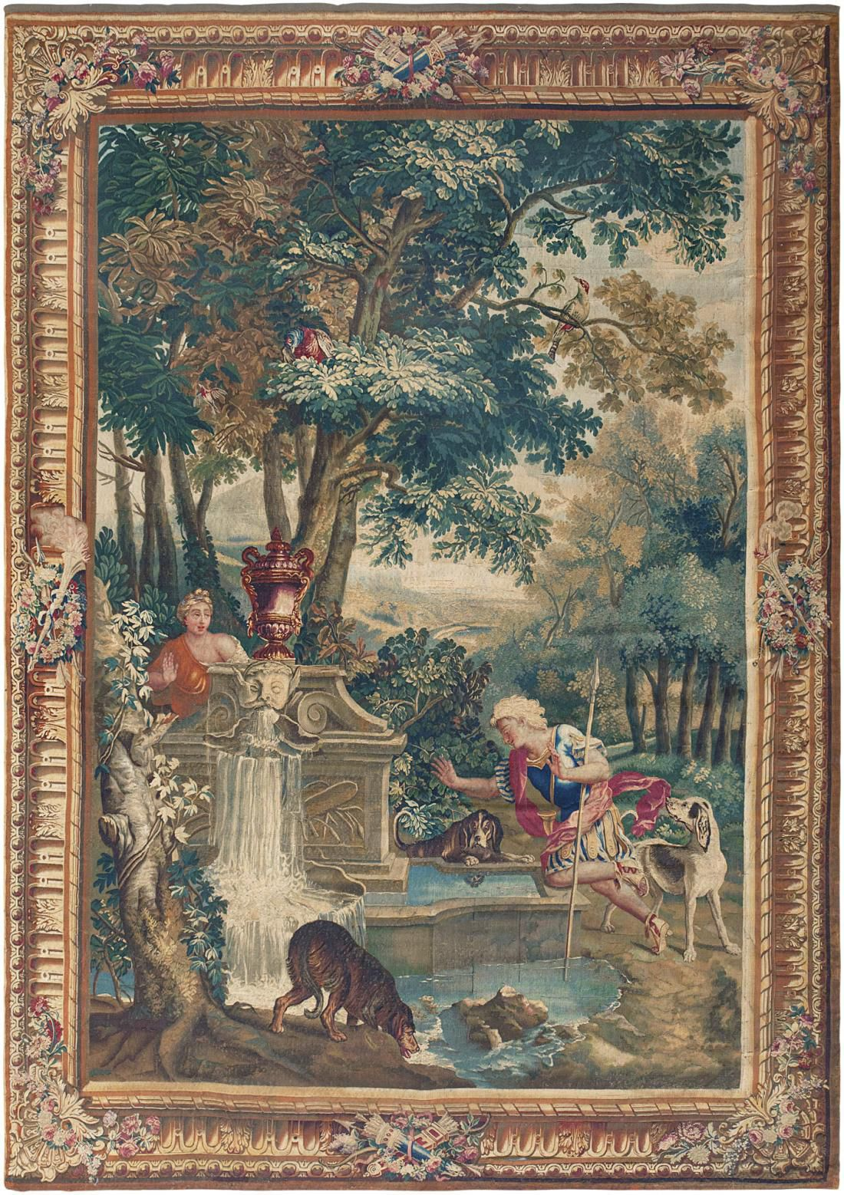**Figure 1: 19th Century tapestry created at the Gobelins Tapestry Works.**

**Figure 2: Bathers at Asnièrs (1884) Georges Seurat**

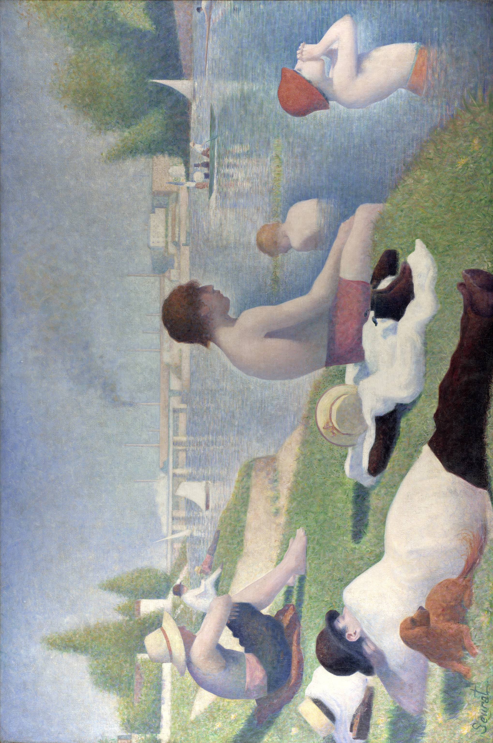

**Figure 3: Bathers at Asnièrs - Close up of Boy’s Hat - Georges Seurat**

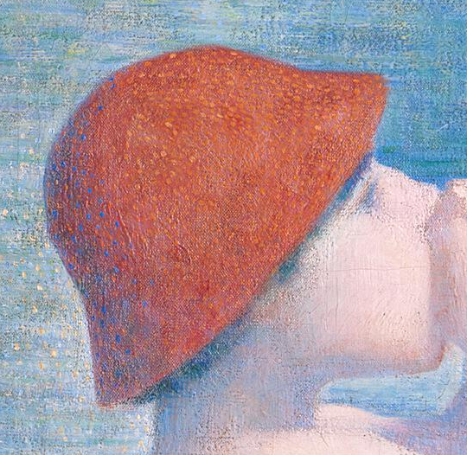

**Figure 4: A Sunday Afternoon on the Island of La Grande Jatte, Georges Seurat (1886)**

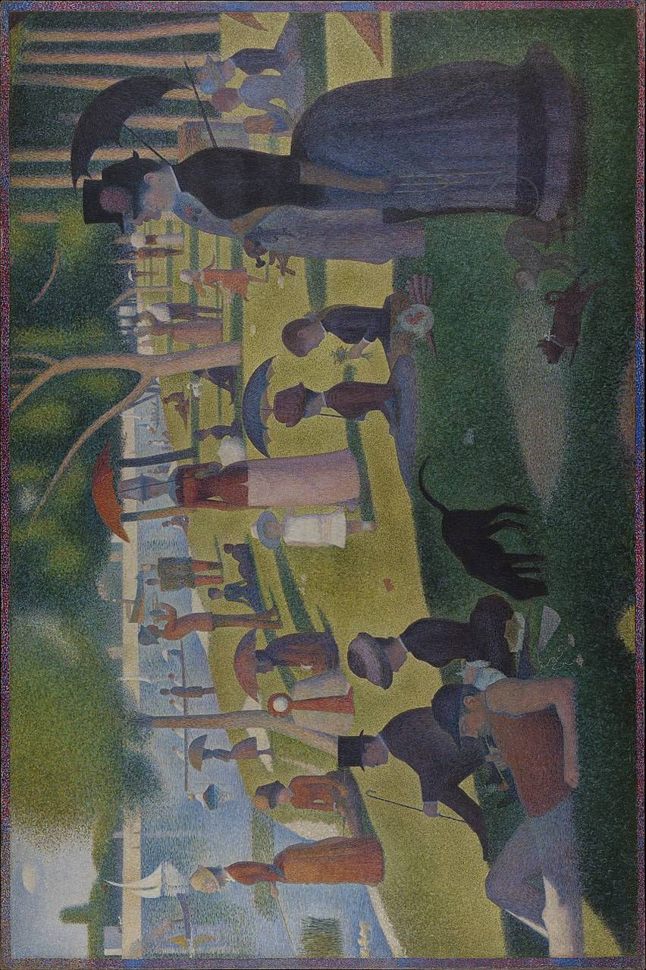

**Figure 5: Georges Seurat - Close up of the face of the young girl in the white dress.**

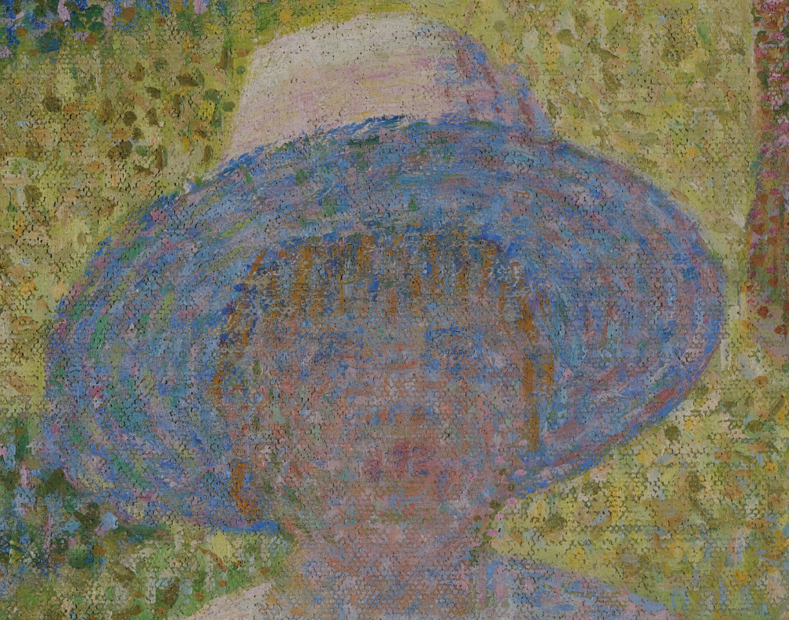

**Figure 6: Belle Île En Mer (1904) - John Russell**

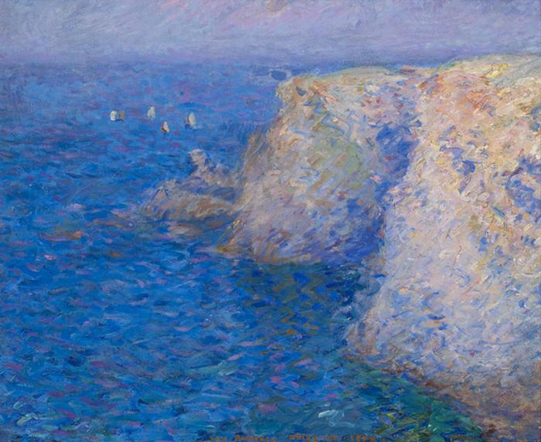

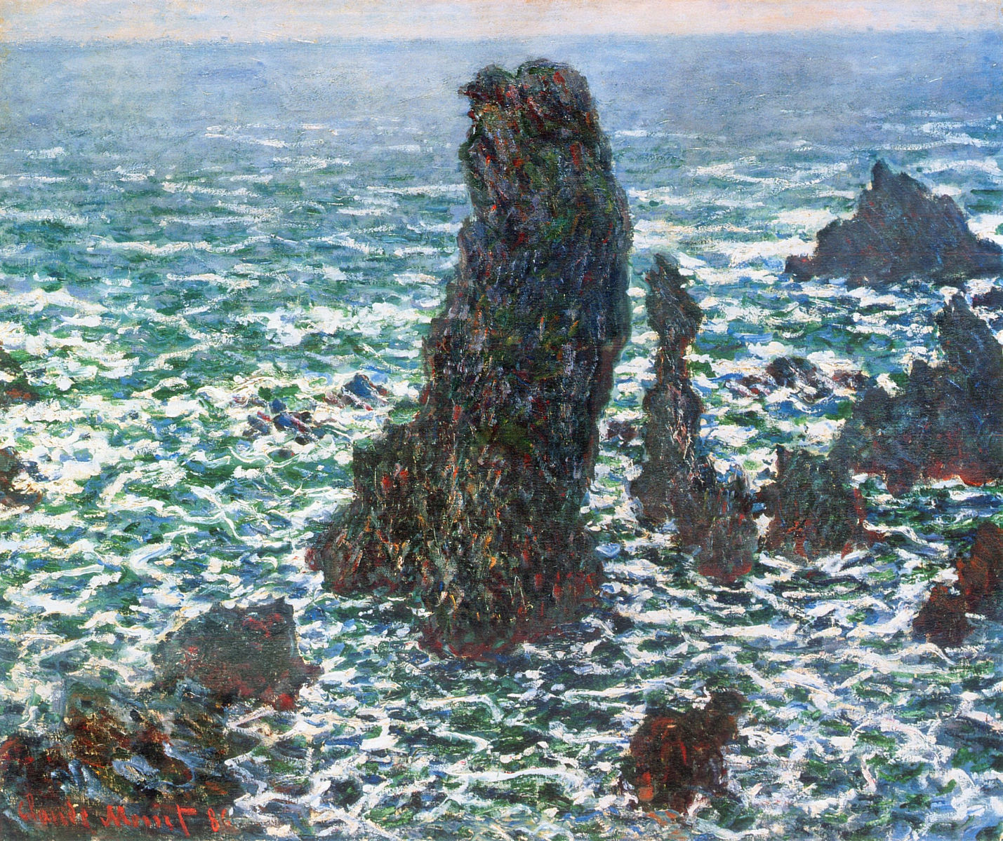

**Figure 7: The Pyramids of Port Coton (1886) Claude Monet**

**Figure 8: The Starry Night (1889) Vincent Van Gogh**

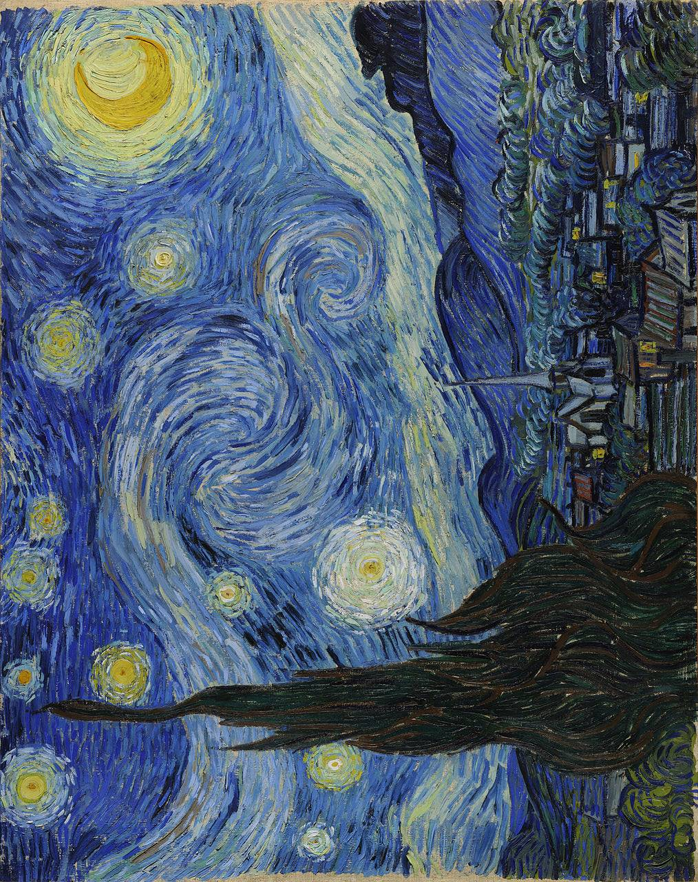

**Figure 9: A Wheatfield With Cypressess (1889) Vincent Van Gogh**

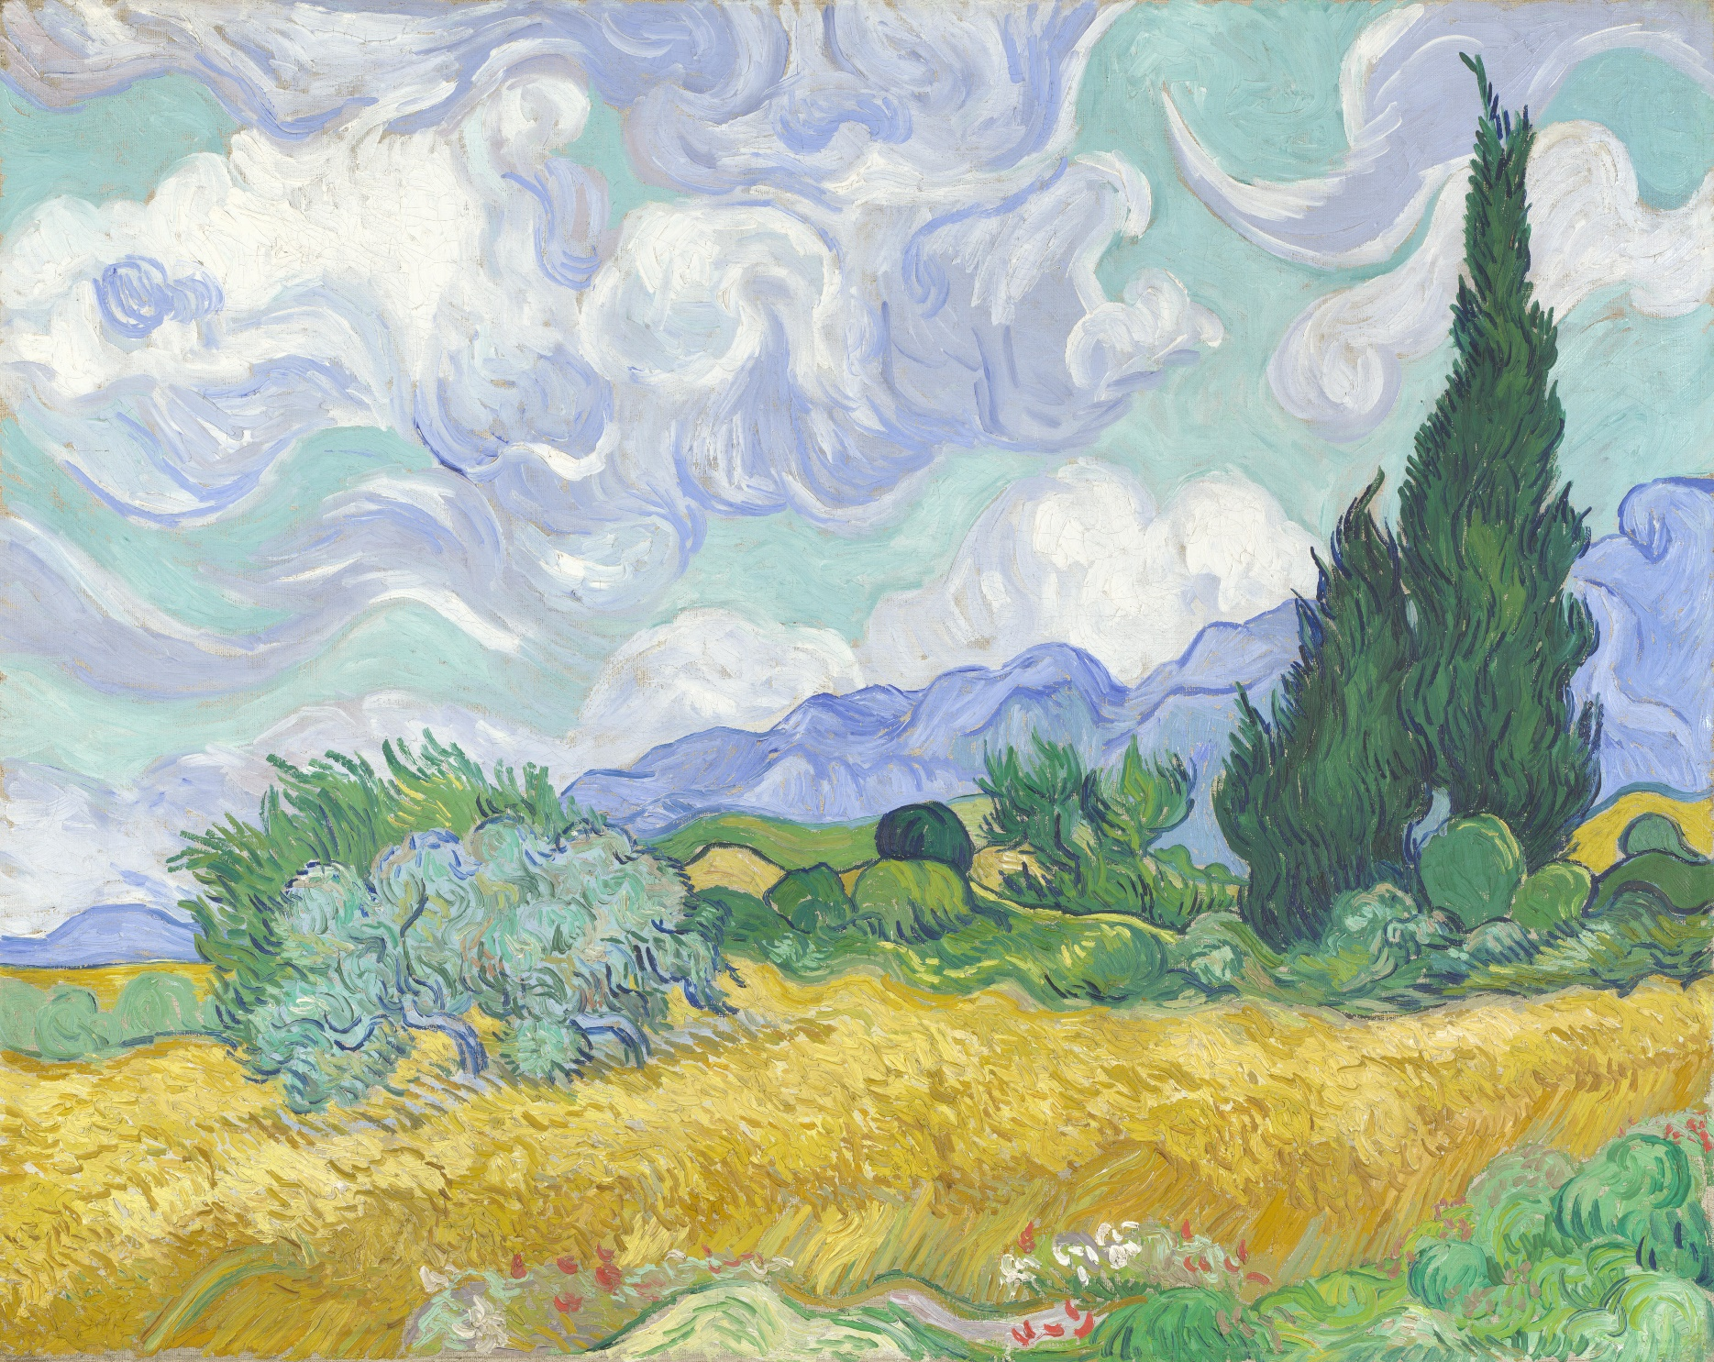

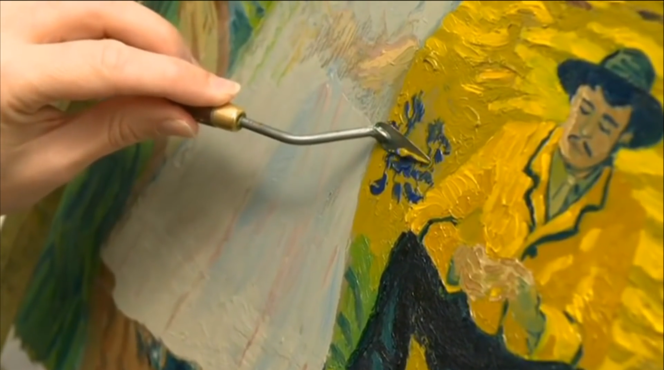**Figure 10: Image showing the process of scraping paint off a canvas used in *Loving Vincent*.**

**Figures 11, 12 and 13: Images showing the process of 3D modelling and then the final painting used in *Loving Vincent*.**

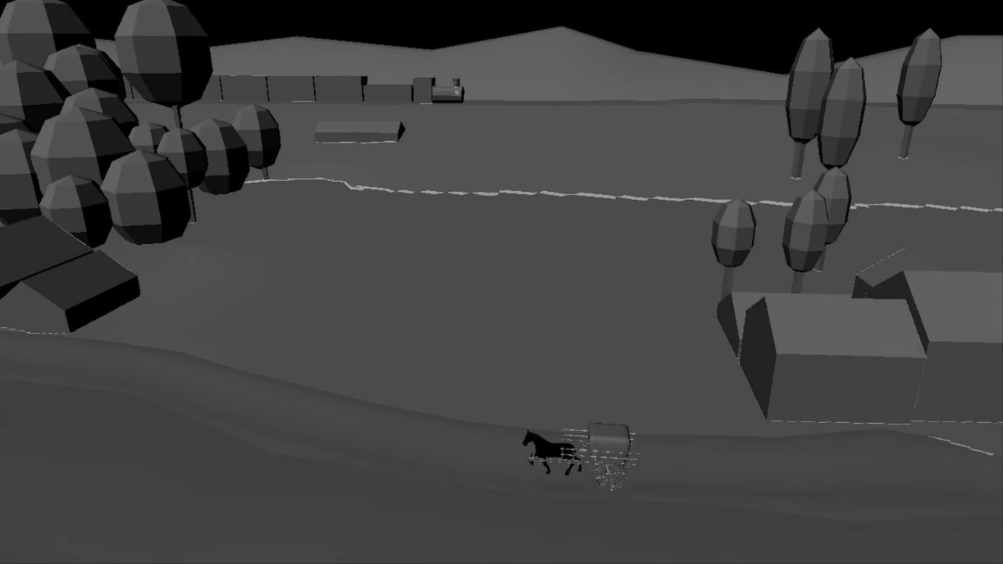

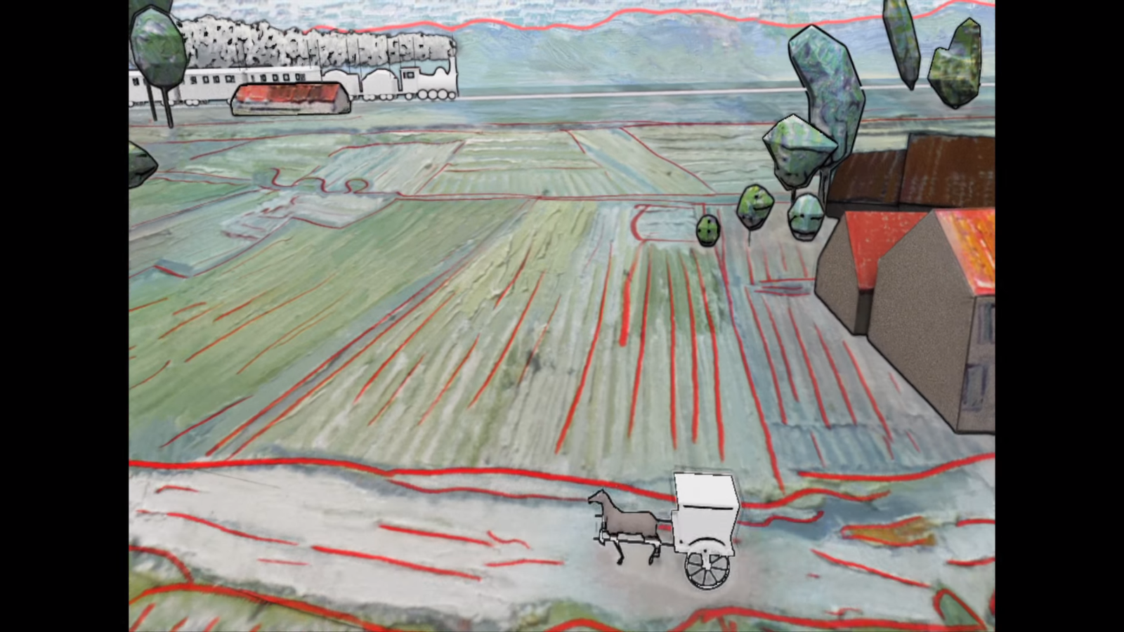

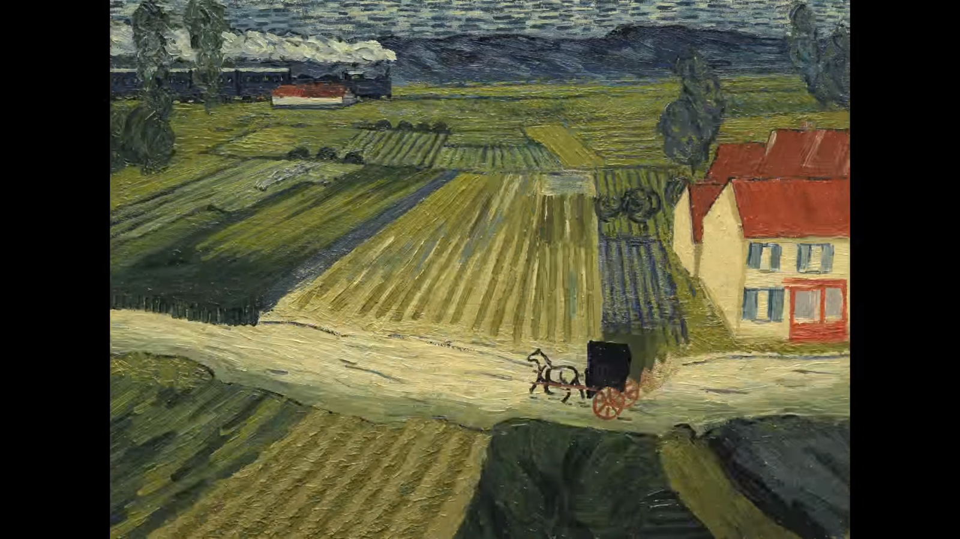

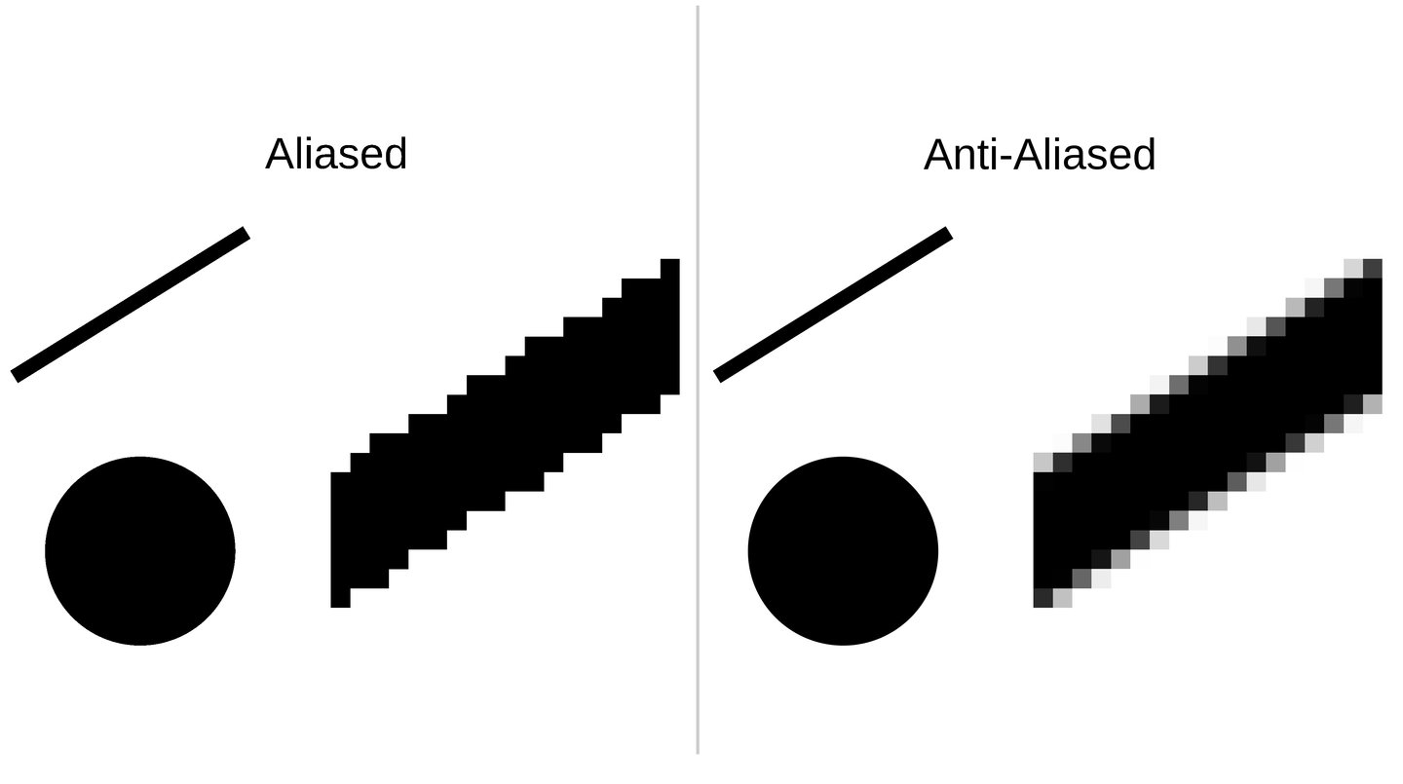

**Figure 14: Image of points from inkjet printer.**

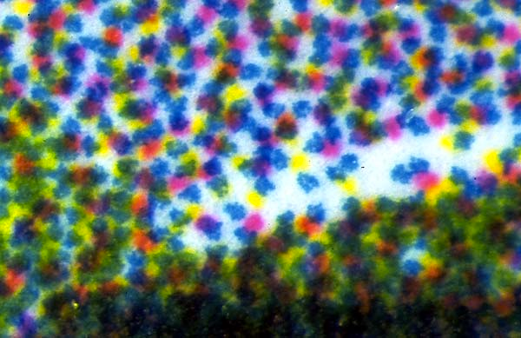

**Figure 15: Image of different types of pixels up close.**

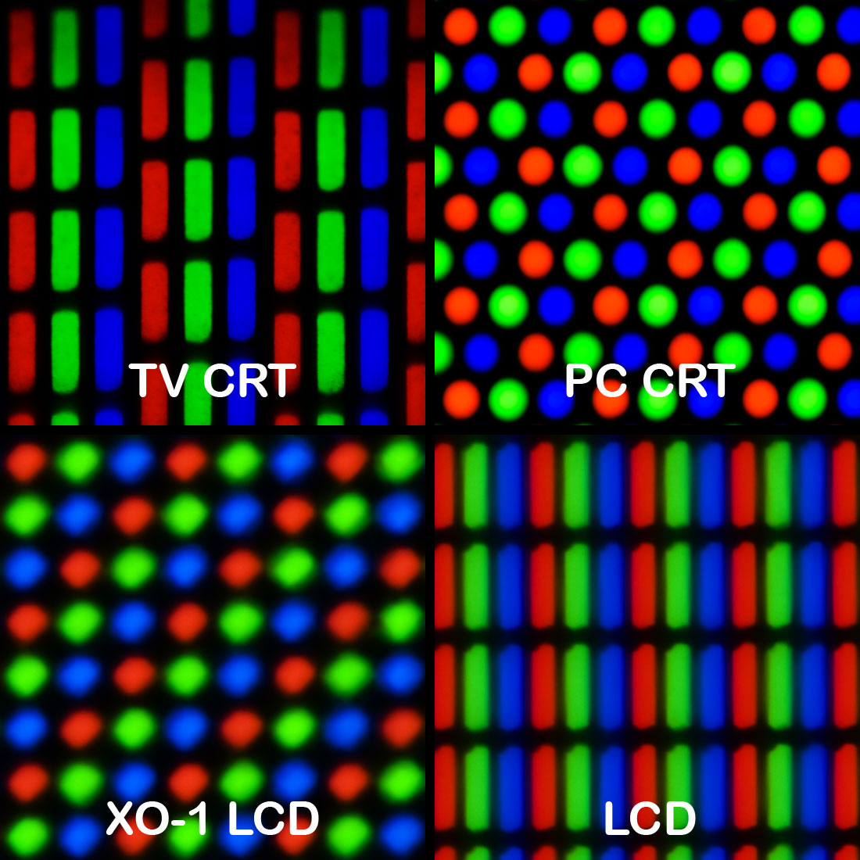

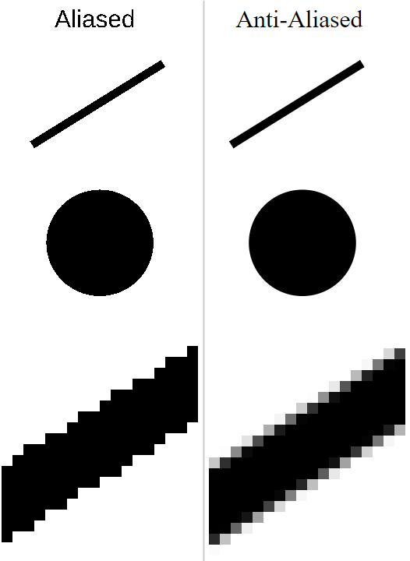**Figure 16: Comparison of Aliasing and Anti-Aliasing.**

**Figure 17: Example of physical dithering on fabric.**

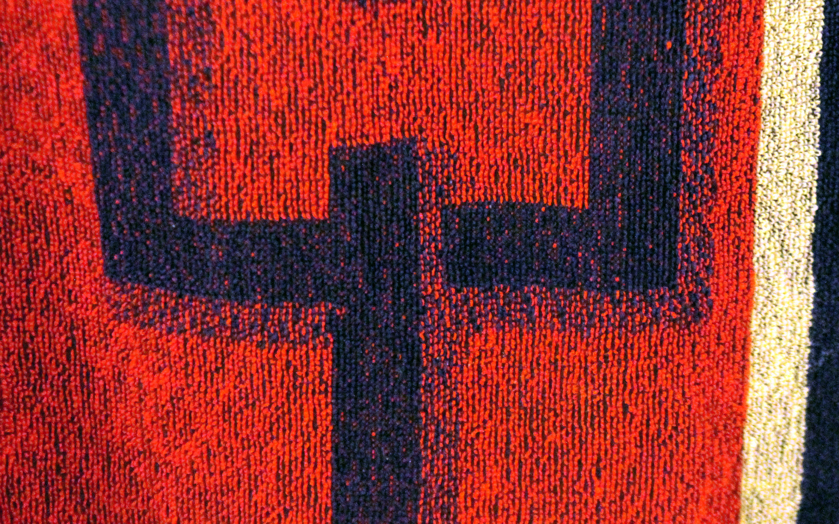

**Figure 18 and 19: Comparison of different types of dithering.**

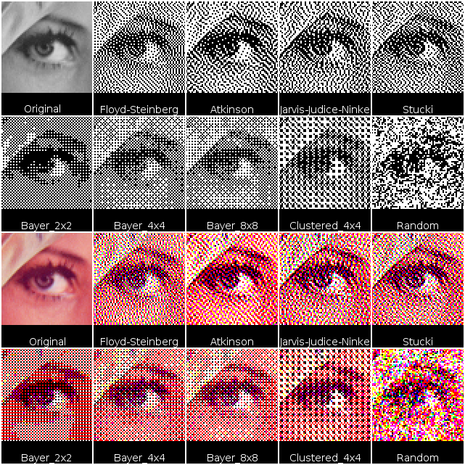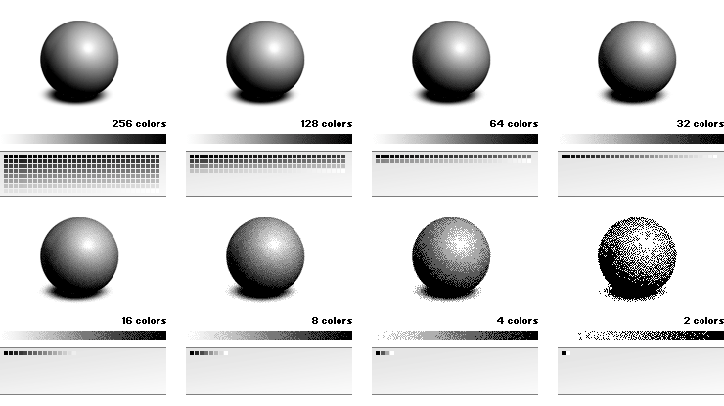

# Figure Sources

1.   Nazmiyal Antiques (2017) [Internet], Available at: https://nazmiyalantiquerugs.com/antique/french/tapestries/antique-18th-century-french-mythological-tapestry-46567/. [Accessed 15 December 2017].

2.  National Gallery, London (2017) Bathers at Asnières [Internet], Available at: https://www.nationalgallery.org.uk/paintings/georges-seurat-bathers-at-asnieres [Accessed 13 December 2017].

3.    National Gallery, London (2017) Bathers at Asnières [Internet], Available at: https://www.nationalgallery.org.uk/paintings/georges-seurat-bathers-at-asnieres [Accessed 13 December 2017].

4.   Google Arts & Culture (2017) A Sunday on La Grande Jatte [Internet], Available at: https://artsandculture.google.com/asset/a-sunday-on-la-grande-jatte/twGyqq52R-lYpA [Accessed 11 December 2017].

5.   Google Arts & Culture (2017) A Sunday on La Grande Jatte [Internet], Available at: https://artsandculture.google.com/asset/a-sunday-on-la-grande-jatte/twGyqq52R-lYpA [Accessed 11 December 2017].

6.   Australian Art Auction Records (2017) John Peter Russell (1858-1930) Australia Paintings [Internet], Available at: https://www.artrecord.com/index.cfm/artist/6732-russell-john-peter/medium/1-paintings/ [Accessed 11 December 2017].

7.   WikiArt (2017) The Pyramids of Port Coton, Belle-Ile-en-Mer [Internet], Available at: <https://www.wikiart.org/en/claude-monet/the-pyramids-of-port-coton-belle-ile-en-mer>. [Accessed 13 December 2017].

8.   WikiArt (2017) Starry Night, Van Gogh [Internet], Available at: <https://www.wikiart.org/en/vincent-van-gogh/the-starry-night-1889>. [Accessed 13 December 2017]

9. WikiArt (2017) Wheatfield with Cypress Tree, Van Gogh [Internet], Available at: <https://www.wikiart.org/en/vincent-van-gogh/wheatfield-with-cypress-tree-1889>. [Accessed 13 December 2017]

10. YouTube (2016) Loving Vincent: The world’s first fully painted feature film. [Internet], still taken from: <https://www.youtube.com/watch?v=0CQKHWvK8Ro> [Accessed 4 January 2018]

11. YouTube (2016) Loving Vincent: Behind the Scenes. [Internet], stills taken from: <https://www.youtube.com/watch?v=eOtwJL4iV8s> [Accessed 4 January 2018]

12. YouTube (2016) Loving Vincent: Behind the Scenes. [Internet], stills taken from: <https://www.youtube.com/watch?v=eOtwJL4iV8s> [Accessed 4 January 2018]

13. YouTube (2016) Loving Vincent: Behind the Scenes. [Internet], stills taken from: <https://www.youtube.com/watch?v=eOtwJL4iV8s> [Accessed 4 January 2018]

14. The American Institute for Conservation (2011) Computer Imaging Technology: The Process of Identification [Internet], Available at: <https://cool.conservation-us.org/coolaic/sg/bpg/annual/v15/bp15-08.html> [Accessed 11 December 2017]

15. Wikimedia (2008) Wikimedia Commons [Internet], Available at: <https://commons.wikimedia.org/wiki/File:Pixel_geometry_01_Pengo.jpg> [Accessed 11 December 2017]

16. Wikimedia (2014) Wikimedia Commons [Internet], Available at: <https://commons.wikimedia.org/wiki/File:Anti-aliasing_demo.svg> [Accessed 3 January 2018]

17. Wikimedia (2014) Wikimedia Commons [Internet], Available at: <https://commons.wikimedia.org/wiki/File:Color_dithering_on_a_towel.jpg> [Accessed 7 January 2018]

18. IDIS (2017) Dithering (Tramado) [Internet], Available at: http://proyectoidis.org/dithering/ [Accessed 21 January 2018]

19. Getit01 (2011) Getit01 [Internet], Available at: <https://www.getit01.com/p2017121188721/> [Accessed 30 January 2018]